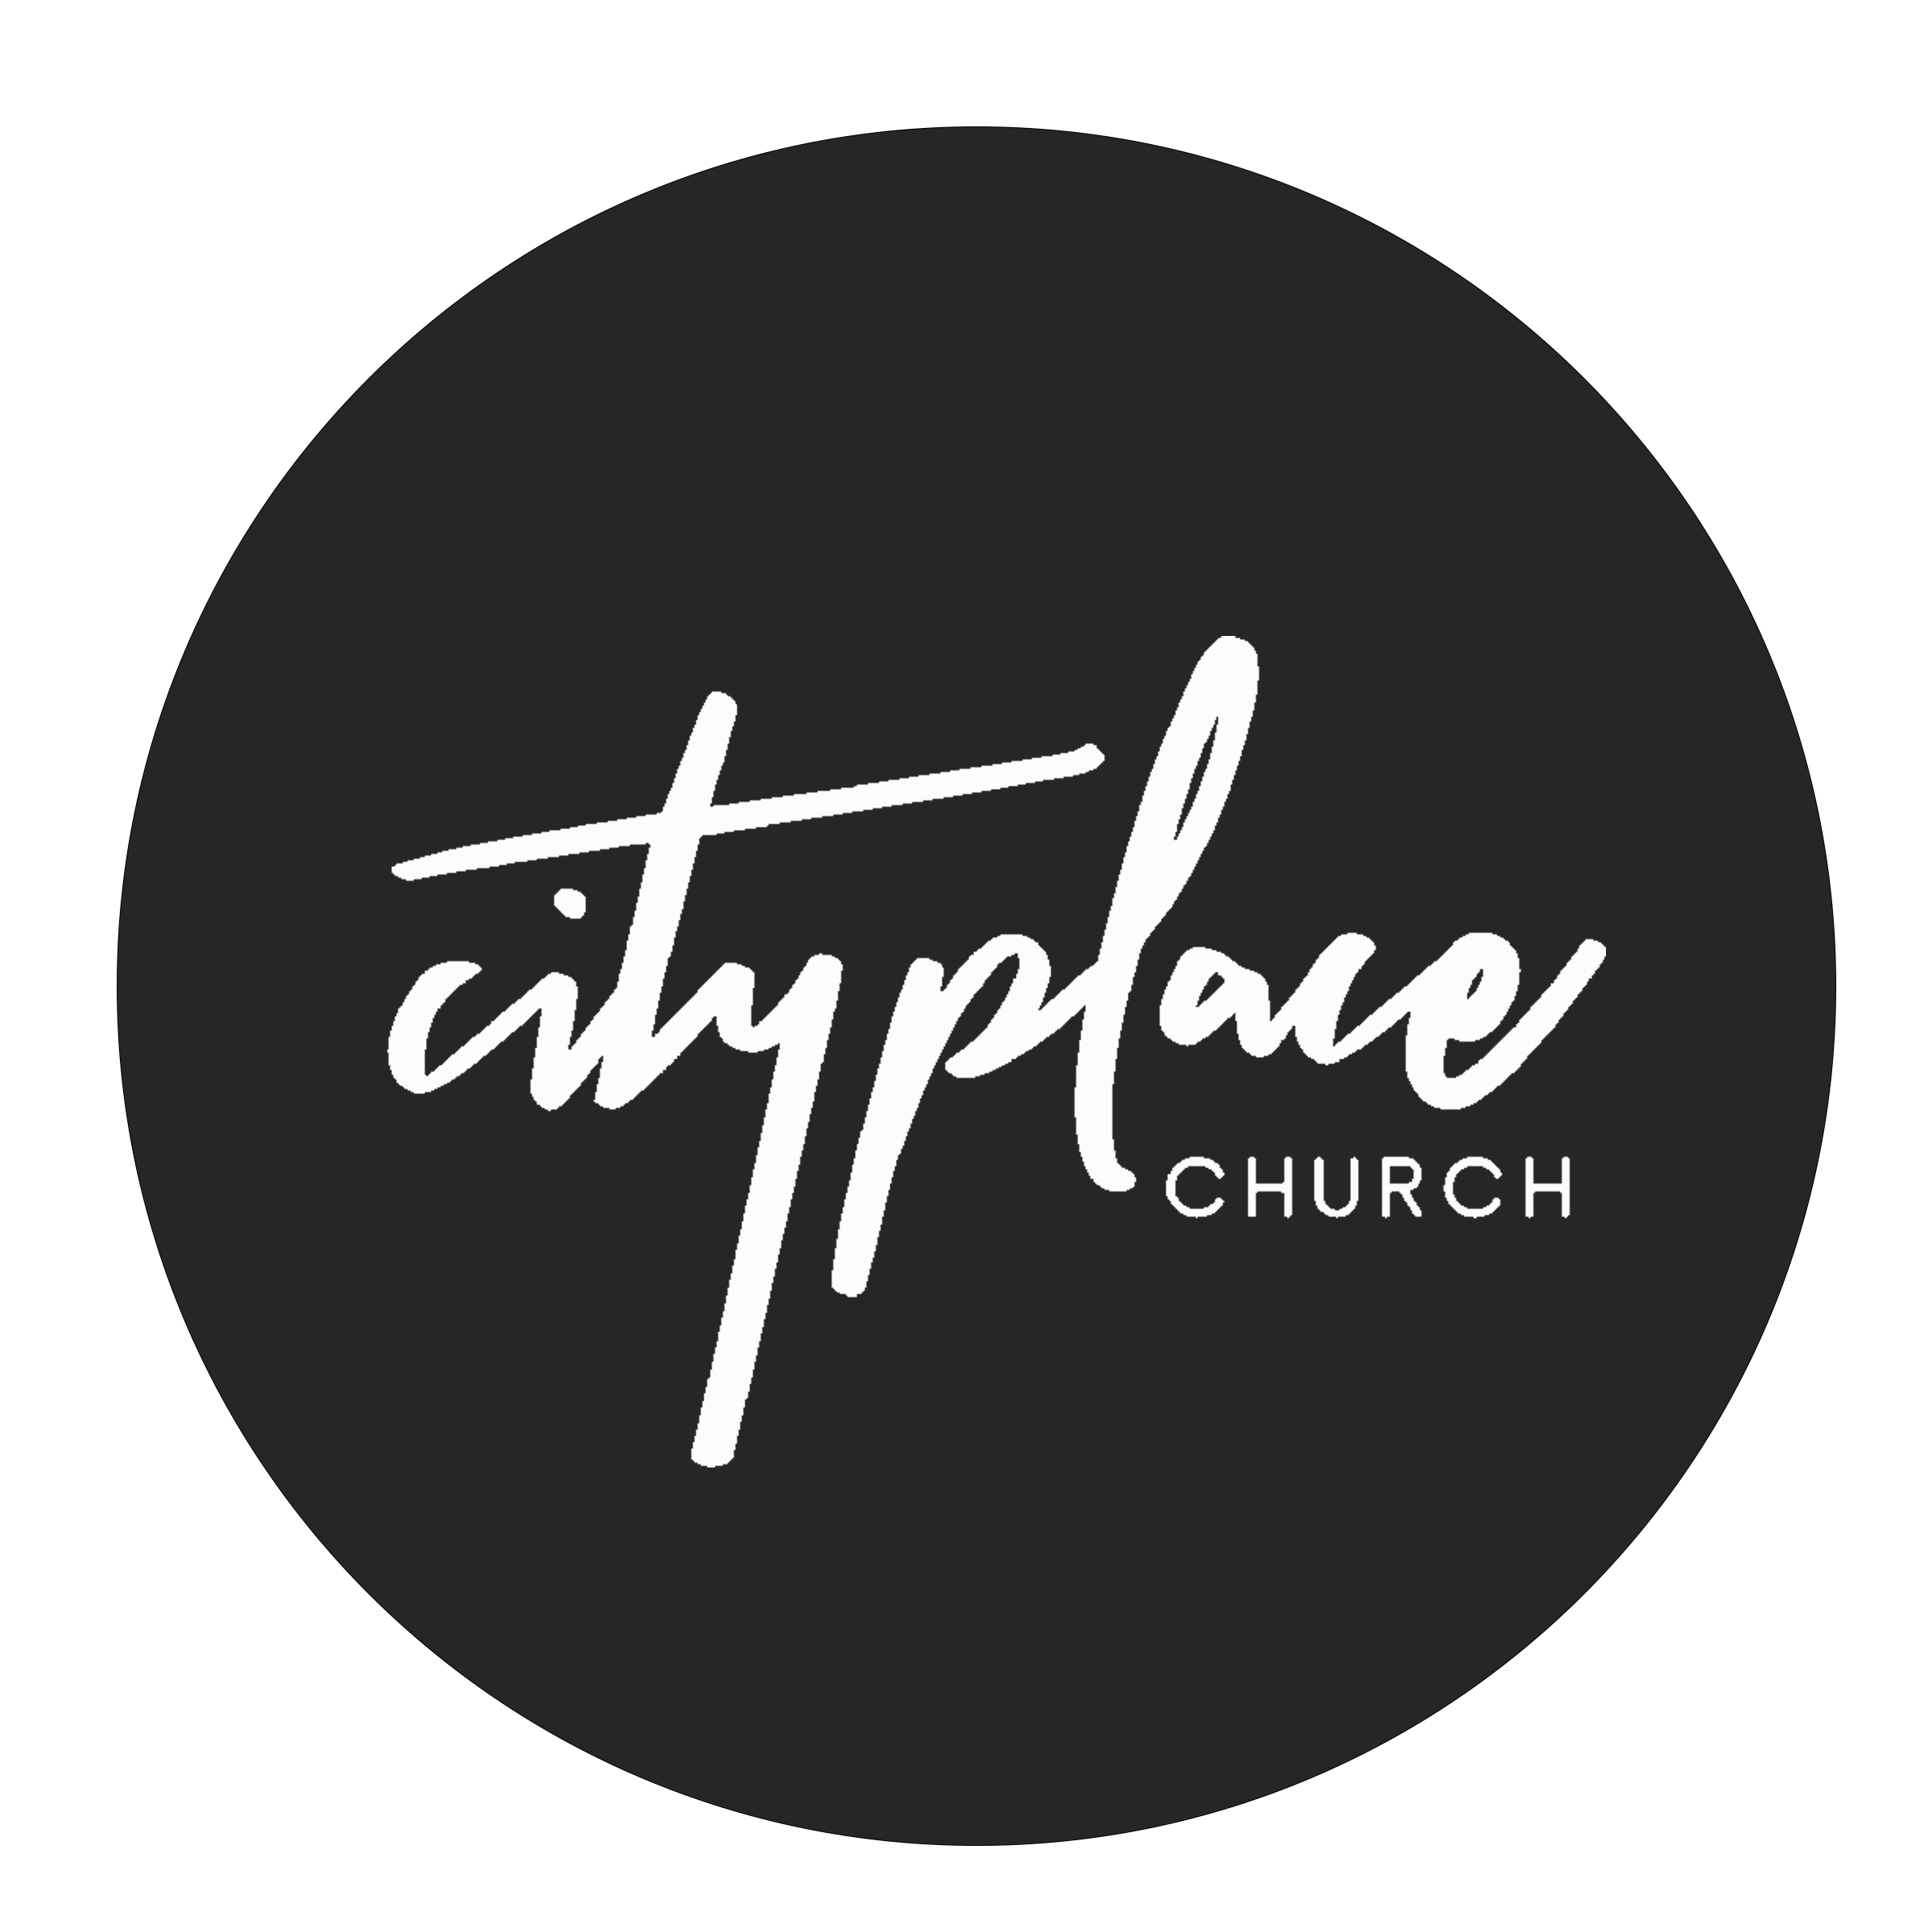

How It All Got Started! Week 3
Damon Moore | November 19, 2023

Habakkuk 2:1-4 NIV I will stand at my watch and station myself on the ramparts (tower); I will look to see what he will say to me, and what answer I am to give to this complaint. 2 Then the Lord replied: “Write down the revelation and make it plain on tablets so that a herald may run with it.3 For the revelation awaits an appointed time; it speaks of the end and will not prove false.Though it linger, wait for it; it will certainly come and will not delay. 4 “See, the enemy is puffed up; his desires are not upright—but the righteous person will live by his faithfulness—

God wants to shift our thinking from days to DECADES.
Fact: If there is vision at the beginning, there should be vision at the end.
Fact: Most of us underestimate what we can do in the long-term, but we overestimate what we can do in the short-term.
Vision (Chazown)= oracle, prophecy (divine communication)

Fact: No voice. No vision.

Could it be that we don’t see clearly because we aren’t hearing clearly? John 10:3-5

Vision Keys:
- Develop a lifestyle of listening for God’s voice through prayer
- Develop a lifestyle of Honor for God’s Word

Four things that impact God’s voice: (your ability to hear.) | Luke 8:5-8
- Pollution, Distractions, Immaturity, Prepared Heart

God voice brings clarity of vision and Pursuit

Week Three: Four Areas of Vision

God the Father’s vision will always impact his: _______________________________________, ___________________________________________, ______________________________ and ____________________________________________________ but it involves YOU.
Vision in Four Areas
- ____________________________________________

Take Note:

2. ____________________________________________

Take Note:

3.____________________________________________

Take Note:

4.____________________________________________

Take Note:

